LILA BLACK — Player Journey Visualization Tool

1. What You Built With and Why You Picked It
Layer | Choice | Why
Data pipeline | Python (pyarrow + pandas) | Strong parquet support; one-time preprocessing at build time; no need for a runtime backend.
Frontend | React + Vite | Fast dev loop, component model fits filter-heavy UI; Vite gives quick HMR and small production bundles.
Rendering | HTML5 Canvas | ~89K data points (paths + events) need high-performance drawing; DOM-based markers would not scale.
Styling | Vanilla CSS + custom properties | No UI framework; full control over layout and glassmorphism-style panels.
Deployment | Vercel / Netlify (static) | Data is pre-processed to JSON at build time — no server or API required; simple static deploy.

Summary: The stack is chosen for speed of load (precomputed JSON), smooth interaction (Canvas for many points), and simple hosting (static site only).

2. How Data Flows From Parquet Files to What Shows on Screen
End-to-end flow: raw parquet → Python preprocessing → static JSON → React app → Canvas.

2.1 High-level data flow
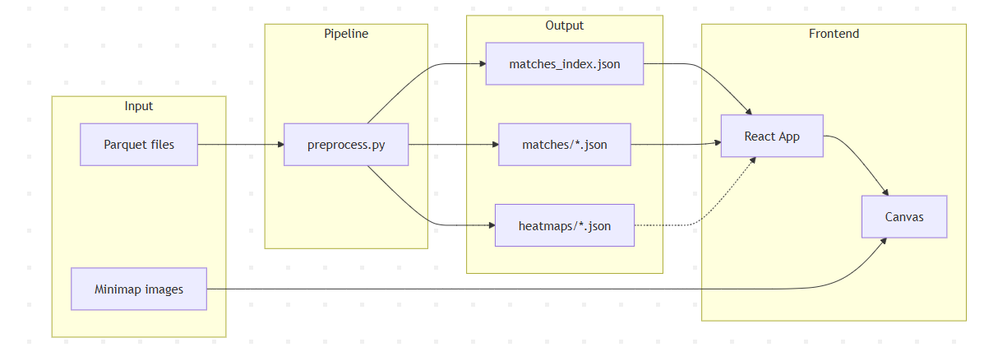

2.2 Detailed pipeline steps

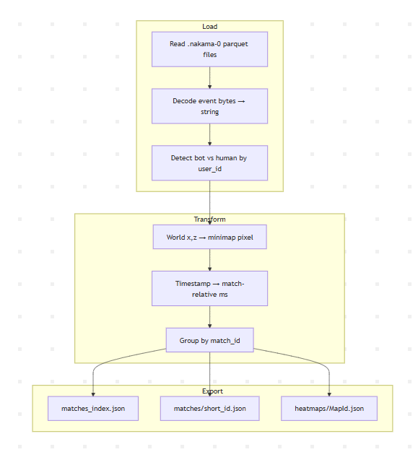

2.3 Detailed Steps
- Raw input: Parquet files (no .parquet extension) under date folders (e.g. February_10 … February_14). Each row has: match_id, map_id, user_id, x, z, y, ts, event.
- Preprocess (Python):
  - Read all parquet files with pyarrow.
  - Decode event from bytes to string.
  - Mark bots (numeric user_id) vs humans (UUID).
  - Convert world (x, z) to minimap pixel (px_x, px_y) using map-specific scale and origin.
  - Normalize ts to match-relative milliseconds (ts_rel).
  - Group by match; write one JSON per match under public/data/matches/{short_id}.json.
  - Build matches_index.json (map, date, match id, player counts, duration).
  - Optionally pre-compute 64×64 heatmap grids per map → public/data/heatmaps/{MapId}.json.
- Frontend:
  - On load: fetch matches_index.json.
  - On match select: fetch matches/{short_id}.json.
  - Timeline: filter events with ts_rel ≤ position × duration_ms and render paths/markers up to that time.
  - Heatmap: in this app, computed in the browser from the current match’s events (same 64×64 grid logic); could be switched to precomputed heatmap JSON.
  - Canvas: draw minimap image, then paths (human vs bot colors), then event markers (kill/death/storm/loot), then heatmap overlay.

3. How Game Coordinates Were Mapped to the Minimap
This is the critical part: world space (game engine) → 1024×1024 minimap image.

3.1 Formula
- Minimap image size: 1024×1024 pixels.
- Each map has a scale and origin (origin_x, origin_z).
- World axes: x, z (horizontal plane); y is elevation and not used for 2D minimap.

Normalized coordinates (0–1):

- u = (world_x - origin_x) / scale
- v = (world_z - origin_z) / scale

Pixel coordinates (0–1024):

- pixel_x = u * 1024
- pixel_y = (1 - v) * 1024

The (1 - v) flips the vertical axis because image origin is top-left while the game world often has Z increasing in the opposite direction.

3.2 Map config
Map | Scale | Origin X | Origin Z
AmbroseValley | 900 | -370 | -473
GrandRift | 581 | -290 | -290
Lockdown | 1000 | -500 | -500

3.3 Coordinate mapping flow
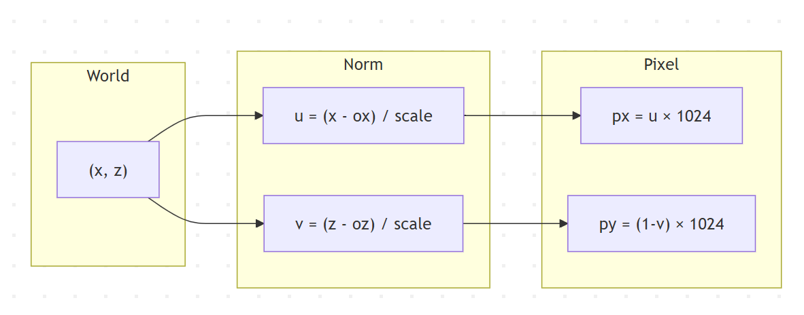

3.4 Verification
For AmbroseValley: world (-301.45, -355.55) → pixel (78.0, 890.4).
Implementation in scripts/preprocess.py uses the same formula and rounds to one decimal; this was checked during development to confirm alignment with the.

3.5 In the frontend
Preprocessing already writes pixel coordinates (px_x, px_y) into the match JSON. The Canvas uses a fixed internal size (e.g. 700×700) and scales those pixel coords by CANVAS_SIZE / 1024 when drawing, so no coordinate math is done in the browser — only scaling and zoom/pan transforms.

4. Assumptions When the Data Was Ambiguous
What was ambiguous | Assumption / handling
Timestamp semantics | “time elapsed within the match,” but values looked like milliseconds since epoch. We treated them as absolute ms and normalized per match by subtracting the minimum timestamp in that match so that playback is 0–duration_ms.
Bot vs human | numeric user_id = bot, UUID = human. We used regex ^\d+$ on user_id to classify; any all-numeric id is treated as bot.
February 14 partial data | Some days might have fewer files. We included all available dates; no special handling. Missing folders are skipped with a warning.
Parquet file extension | Files had no .parquet extension. We passed paths directly to pyarrow.parquet.read_table(); no renaming.
Event column type | event could be bytes. We decode to UTF-8 string when needed and handle non-bytes by casting to string.
match_id suffix | Some IDs had .nakama-0. We strip that for grouping and use a short hash (e.g. first 10 chars of MD5) for filenames.

5. Major Trade-offs
Decision | Options considered | Choice | Trade-off
Data format for frontend | Serve parquet + query in browser (e.g. DuckDB-WASM) vs pre-process to JSON | Pre-process to JSON at build time | Fast load, no backend. Reprocess and redeploy when data changes.
Rendering | SVG/DOM vs Canvas vs WebGL | HTML5 Canvas | Handles ~89K points smoothly. No built-in “click path for tooltip”; would need hit-testing.
Match data granularity | One big JSON vs one file per match | One JSON per match | Small per-match fetch (~5–20KB). No “all matches on one map” view without extra aggregation.
Heatmap resolution | 32×32 vs 64×64 vs 128×128 | 64×64 | Good visual smoothness and fast to compute. Very tight clusters can blur.
Heatmap source | Precomputed global (heatmaps/*.json) vs per-match in client | Per-match in client (current app) | Heatmap always matches selected match. Slightly more client work; global heatmaps could be added for “all matches” view.
Timeline playback | Real-time only vs scrubbable + play | Scrubbable slider + play/pause + speed | Level designers can scrub and replay. Playback uses requestAnimationFrame for smoothness.

